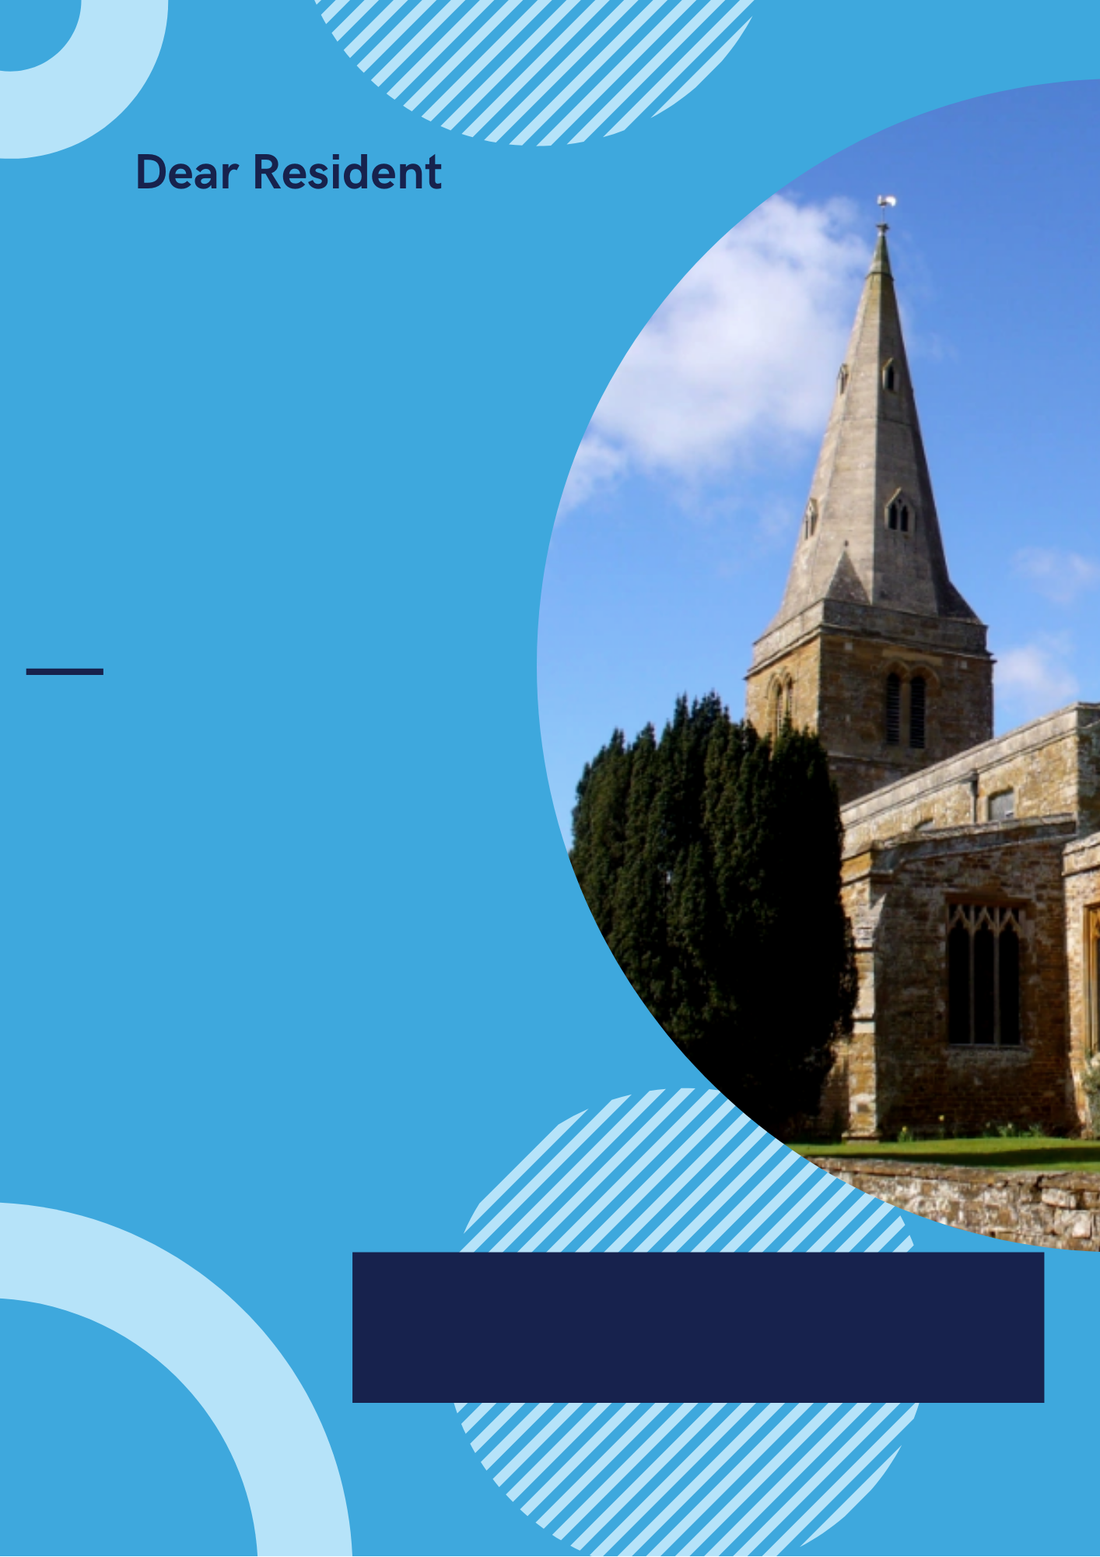

www.pdg.org.uk

With the easing of lockdown restrictions, we are allowed to gather in groups for social activities. This includes ringing the church bells again.

Not having rung in some time, we may be out of practice. We hope that our ringing will improve as we brush away the cobwebs.

It has not been possible to mark many occasions in the last year with bells, be they joyful for a wedding or sorrowful for a loss. If you have an occasion in the last year that you would like to mark by ringing, please get in touch and we can discuss arranging some ringing to mark your event.

The pandemic has resulted in many restrictions on what we could all do over the last year or so. We’ve not been able to celebrate or commiserate with friends and family, and we’ve not been allowed to meet in social situations.

The restrictions on gathering has meant that the bells of the church have not been able to ring/not been able to ring fully since March last year.

**Starting \*\* June 2021**

**Sunday morning from \*\* am**

**Wednesday evening from \*\*\* pm**