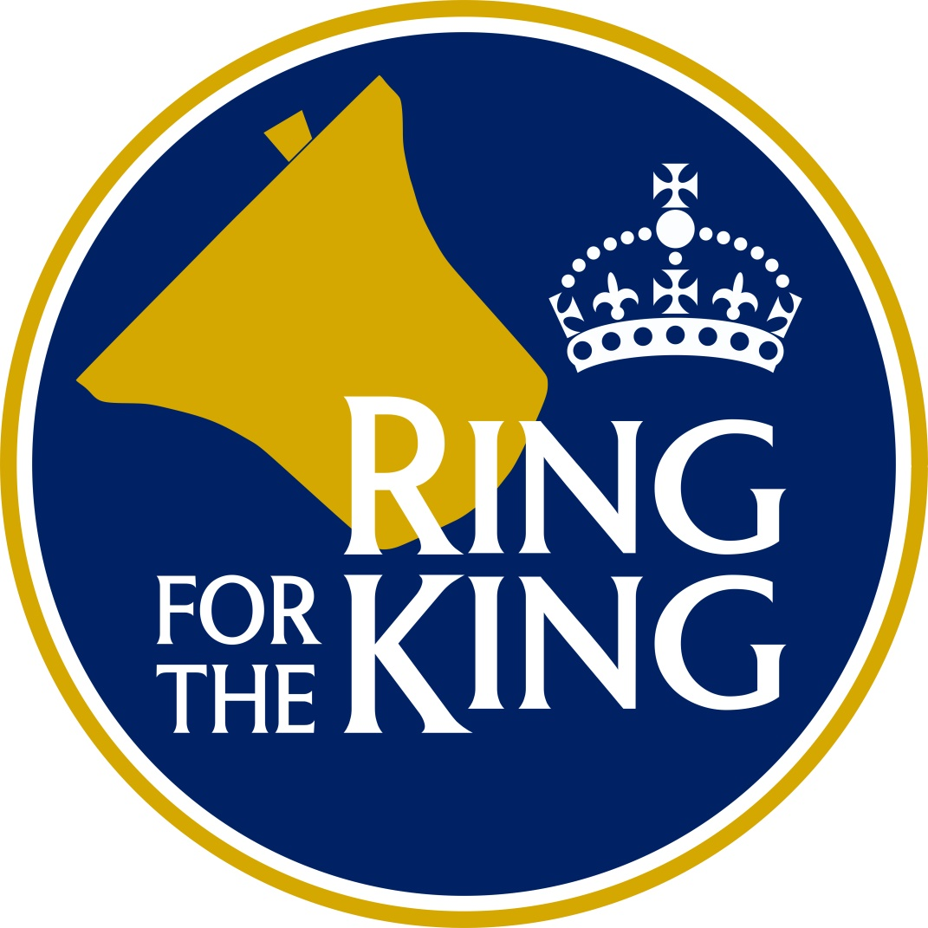

Why not train to be a bell ringer in time to

ring for the King’s coronation

on 6th May 2023

If you want to have a go, please contact:

……………………………………….

**Have you ever wanted to**

**try Bell Ringing?**